Sarita Shivdas Tathe

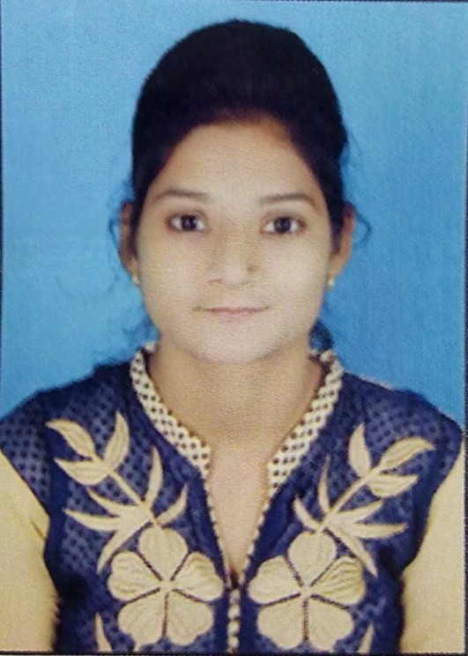

Web Developer

[tathe.sarita19@gmail.com](mailto:tathe.sarita19@gmail.com)

+918698180735

Karanja (Lad) Dist. Washim

Birth date:24 September 1995

EDUCATION Bachelor of Engineering (B.E), Computer Engineering(2018).

Dr. Bhausaheb Nandurkar College Of Engineering And Technology, Yavatmal.

Percentage: 64.50%

HSC(2011 - 2012)

Vidyabharti Jr. College Karanja (lad)

Percentage: 50.00%

SSC**(**Secondary**)**

Year of completion: 2010

MAHARASHTRA BOARD OF SECONDARY AND HIGHER SECONDARY SCHOOL PUNE Board

VIshwabharti Vidyalaya Karanja (Lad)

Percentage: 78.00%

INTERNSHIP 3 months internship at ICEICO Technology PVT LTD, Nagpur

Web Developer

22 MARCH 19 to 26 JUNE 19

PROJECTS Beyond tribe English Medium School

Link: beyondtribe.in

It was school website that I have designed using bootstrap framework, css and html. It was static website. I worked on that project’s frontend individually. It takes 1 month to complete.

|  |  |  |  |  |
| --- | --- | --- | --- | --- |
| SKILLS | HTML  Intermediate | CSS  Intermediate | JavaScript  Beginner | Bootstrap 3,4  Intermediate |
|  | PHP  Beginner | SQL  Beginner | JQUERY  Beginner |  |

**Date: Yours Sincerely,**

Sarita Tathe